Analyzing Venice High School weather data for use in the classroom
Sample Data from log file 112006lgcsv60.csv
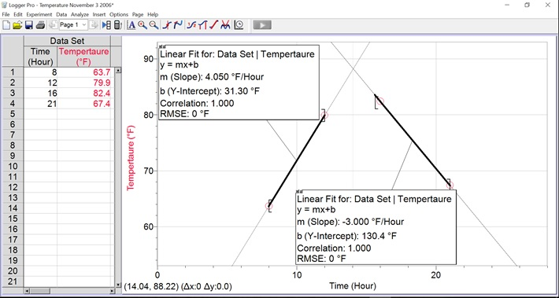
Day | Month | Year | Hour | Minute | Temperature
3 | 11 | 2006 | 0 | 0 | 69.3
3 | 11 | 2006 | 1 | 0 | 68.1
3 | 11 | 2006 | 2 | 0 | 68.1
3 | 11 | 2006 | 3 | 0 | 67.1
3 | 11 | 2006 | 4 | 0 | 66.4
3 | 11 | 2006 | 5 | 0 | 66.4
3 | 11 | 2006 | 6 | 0 | 64.5
3 | 11 | 2006 | 7 | 0 | 64
3 | 11 | 2006 | 8 | 0 | 63.7
3 | 11 | 2006 | 9 | 0 | 68.8
3 | 11 | 2006 | 10 | 0 | 73.5
3 | 11 | 2006 | 11 | 0 | 76.3
3 | 11 | 2006 | 12 | 0 | 79.9
3 | 11 | 2006 | 13 | 0 | 81.4
3 | 11 | 2006 | 14 | 0 | 82.6
3 | 11 | 2006 | 15 | 0 | 82.4
3 | 11 | 2006 | 16 | 0 | 82.4
3 | 11 | 2006 | 17 | 0 | 79.4
3 | 11 | 2006 | 18 | 0 | 74.9
3 | 11 | 2006 | 19 | 0 | 71.6
3 | 11 | 2006 | 20 | 0 | 68.9
3 | 11 | 2006 | 21 | 0 | 67.4
3 | 11 | 2006 | 22 | 0 | 66.1
3 | 11 | 2006 | 23 | 0 | 65

- Find appropriate data from logfiles.
  - Visit Venice High School Weather Site
  - http://sarasotacountyschools.net/schools/venicehigh/
  - Navigate to website menu Weather
  - Scroll down to Historical Data
  - Select Log Files
  - Download 112006lgcsv60.csv
- The goal is to find the intercept point of two lines. The idea is that the temperature goes up in the morning and down in the evening. Objective: To calculate the time of day when the temperature is at a maximum using temperature data points from the morning and evening by applying the point slope formula.
- Data Points:
  - Morning: 63.7°F at 8 am & 79.9°F at 12 pm - Evening: 82.4°F at 16 hours (4 pm) & 67.4°F at 21h (9 pm)
  - Find slope using $m= \frac{y_{2}- y_{1}}{x_{2} - x_{1}}$
    - Morning: (79.9 – 63.7) / (12 – 8) = 16.2 / 4 = + 4.05 °F/hour
    - Evening: (67.4 – 82.4) / (21-16) = -15 / 5 = -3.00 °F/hour
    - Notice that it warms up quicker than it cool, probably because the earth (trees, soil, etc…) are retaining heat.
  - Put into y = mx + b form by using the point slope formula: y – y₁ = m (x – x₁)
    - Morning
      - y – 63.7 = 4.05 (x – 8)
      - y = 4.05 x + 31.3
    - Evening
      - y – 67.4 = -3.00 (x – 21)
      - y = -3.00 x + 130.4
  - Find intercept time
    - Equation i2 and ii2 are both equal to y so we can set them equal to each other
    - i2 = ii2
    - 4.05 x + 31.3 = -3.00 x + 130.4
    - 7.05 x = 99.1
    - x = 14.06 hours (~2 pm)
- Analysis
  - The intercept of the two lines occurs at 2 pm.
  - If we look at the data table we can see the maximum temperature for that day is actually at 14 hours.
  - We can calculate the maximum theoretical temperature at 14 hours.
    - y = mx + b
    - y = 4.05 x + 31.3
    - y = 4.05 (14) + 31.3
    - y = 88°F
  - The actual maximum temperature is only 82.6°F
  - This can lead into a discussion about how the temperature does not just suddenly change.
- Going Further
  - Other data can be analyzed
    - Monthly temperatures
    - Yearly temperatures
    - UV, Solar Intensity, Humidity, Barometric Pressure
  - Where to view sample data
    - VHS Site
      - Under the top section there is a link: View our older Weather Display Live Flash Format
      - Going to the Graph button you can experiment with other data
      - Other data can be found under Historical Data Daily Weather Report
    - Weather Underground
      - There is an icon/sticker under the Sun and Moon Information that will take you to Weather Underground (WU) www.wunderground.com
      - You can also find the VHS Weather Station by searching the WU website.
      - Various graphs can be created there.

